Bag or Broke: NIL Money Moves — Avatar Personas & Character Arcs


1. Malik “Blueprint” Carter — The Architect
Persona Code: I-L-A-R
Category: Strategic Visionary
Personality & Traits:
- Thoughtful, reserved, methodical
- Obsessed with structure, schedules, and long-term gain
- First to analyze card value, last to blow money on flash
- Mentors other players without losing competitive edge
- Always has a financial plan and a backup plan
Strategic Style:
- Prioritizes green (investment) and purple (growth) spaces
- Skips luxury cards unless resale value exceeds cost
- Uses REP to gain long-term advantages
- Times NIL bonuses to cancel debt or reinvest immediately
Character Arc:
Start: Walk-on with no name recognition, quiet and underestimated
Middle: Starts to dominate investments, quietly building a diverse portfolio
Climax: Makes a lowkey move others overlook that multiplies value late-game
End: Wins not with flash, but with a fortress of value others never saw coming


2. Jada “Ms. Longevity” Thompson — The Legacy Maker
Persona Code: I-L-C-R
Category: Visionary Steward
Personality & Traits:
- Community-minded, humble leader
- More focused on impact than income
- Makes choices with emotional and ethical consideration
- Inspires others by example
- Highly values service, education, and mentorship
Strategic Style:
- Chases career (purple) and REP-based bonuses
- Spends NIL funds on long-term investments, not lifestyle
- Avoids red spaces by playing cautious and smart
- Invests in cards that increase community equity
Character Arc:
Start: Mid-tier recruit with strong academic background
Middle: Gains slow, steady REP and career points, overlooked at first
Climax: Gets hit with a curveball but bounces back due to low debt
End: Wins or finishes strong with legacy built in career + REP points


3. Ava “Prime Time” Taylor — The Hot Shot
Persona Code: S-N-A-R
Category: Flashy Firecracker
Personality & Traits:
- Confident, stylish, lives for the camera
- Quick to jump on NIL deals without reading fine print
- Loud starter, light on follow-through
- Struggles with criticism and long-term discipline
- Social media savvy, but impulsive with money
Strategic Style:
- Takes early luxury cards and NIL bonuses
- Invests late, often when it’s too late
- Rarely earns REP or Career points unless accidental
- Falls victim to curveballs and interest charges
Character Arc:
Start: Starts strong with big NIL earnings and viral moments
Middle: Luxury overload and penalties stack up
Climax: Learns a hard lesson from a major curveball (e.g., lawsuit)
End: Either turns things around slightly or crashes out completely

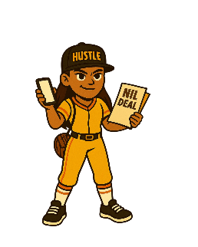
4. Tiana “T-Mo” Morales — The Hustler
Persona Code: I-N-A-V
Category: Relentless Operator
Personality & Traits:
- Street-smart, relentless, entrepreneurial
- Not afraid to take risks or use credit wisely
- Competitive, sometimes cutthroat, but loyal to the grind
- Deals always cooking—has 3 side hustles by Year 2
- Believes every loss can flip into a win
Strategic Style:
- Aggressive investor in green cards
- Uses NIL income to buy plays others skip
- Recovers from curveballs with backup plans
- Picks up REP through hustle-oriented cards (e.g., ad campaigns, pop-ups)
Character Arc:
Start: Underdog from small program with no fanfare
Middle: Stacks two investments quickly but gets hit with credit debt
Climax: Makes a risky move that pays off 100%
End: Finishes with the highest income streams, sometimes outscoring everyone

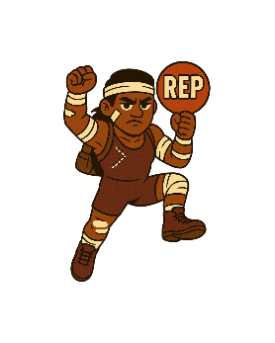
5. Dre “Grit” Johnson — The Survivor
Persona Code: S-L-C-V
Category: Underdog Responder
Personality & Traits:
- Quietly tough, emotionally grounded, compassionate
- Often ignored until late-game
- High EQ, uses empathy to build relationships and legacy
- Finds motivation in adversity
Strategic Style:
- Endures multiple red/blue space hits (injury, emergency)
- Builds REP and career through service and low-cost development cards
- Minimal luxury, minimal risk
- Sometimes leans into luck-based plays late-game
Character Arc:
Start: Tough upbringing, no NIL buzz
Middle: Hit by multiple setbacks, but never folds
Climax: Uses REP and career growth to build a surprising comeback
End: May not win in cash but wins in respect and character arc


6. Preston “The Protégé” Lee — The CEO in Training
Persona Code: I-L-A-C
Category: Future Mogul
Personality & Traits:
- Polished, media trained, brand-ready
- Balanced across all areas
- Treats college like a launchpad for business empire
- Reads every contract; checks every resale value
- Quietly competitive, strategic in every turn
Strategic Style:
- Builds REP + Career evenly while investing consistently
- Uses NIL bonuses as capital, not cash flow
- Will take 1-2 luxury plays if they have endgame resale value
- Rarely caught off-guard
Character Arc:
Start: Top recruit with NIL buzz and clean image
Middle: Makes solid investments and learns fast
Climax: Turns a mid-level card into a multi-track flip
End: Near-perfect balance sheet, strong brand, top-3 finisher every time

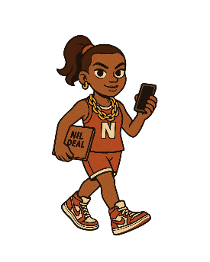
7. Nia “Big Drip” Banks — The Flexer
Persona Code: S-N-C-V
Category: Status Symbol Seeker
Personality & Traits:
- Fashion-forward, trendsetter, influencer energy
- Cares more about being seen than being secure
- Great at marketing but weak at financial planning
- Avoids boring cards like "Budget" or "Workshop"
Strategic Style:
- Buys almost every luxury card
- Uses NIL to show off, not grow
- Usually has low REP/Career points
- Often hits red spaces with no backup funds
Character Arc:
Start: Viral star with NIL chains and custom kicks
Middle: Net worth starts shrinking, but she keeps spending
Climax: May have a wake-up moment (or not)
End: If lucky, flips a few luxuries. If not, finishes broke with high clout


8. Trey “Lights Out” Douglas — The Flameout
Persona Code: S-N-A-V
Category: Unstable Star
Personality & Traits:
- Big personality, ego-driven, high-risk mindset
- Plays like the rules don’t apply
- Relies on early NIL wins to coast
- Impulsive, emotional spender
Strategic Style:
- Chases NIL bonuses fast
- Rarely builds REP or career
- Spends early on luxury and ignores debt
- Prone to big crashes from red/blue spaces
Character Arc:
Start: Viral commitment, big brand deals early
Middle: Totally ignores strategic plays
Climax: Gets hit with major penalties and spirals
End: Learns a lesson... maybe. Or flames out with style and zero cushion

